**Lab 03: Assignment: Ping Utility Analysis**

**Objective**

In this assignment, we will analyse the ping utility, exploring its functionality, usage, and output, and demonstrating understanding through a series of tasks.

**Tasks**

**1. Ping Basics**

**Purpose of the Ping Utility:**

The ping utility is a network diagnostic tool used to test the reachability of a host on an IP network. It also measures the round-trip time for messages sent from the source to the destination. The tool helps determine if a particular host is reachable and assesses network performance.

**2. Ping Output Analysis**

**Running the Command:**

Since I cannot execute commands directly, here is a general structure of the ping output and its analysis:

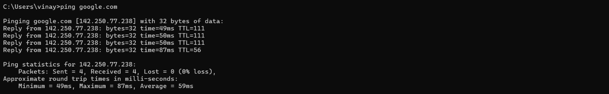

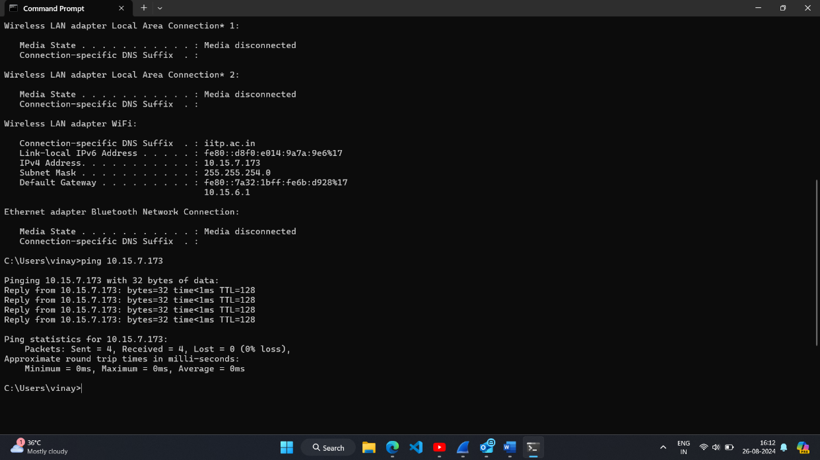

**3. Ping Options (Windows)**

**-n (count)**

**Explanation:**

* Specifies the number of ICMP Echo Request packets to send.

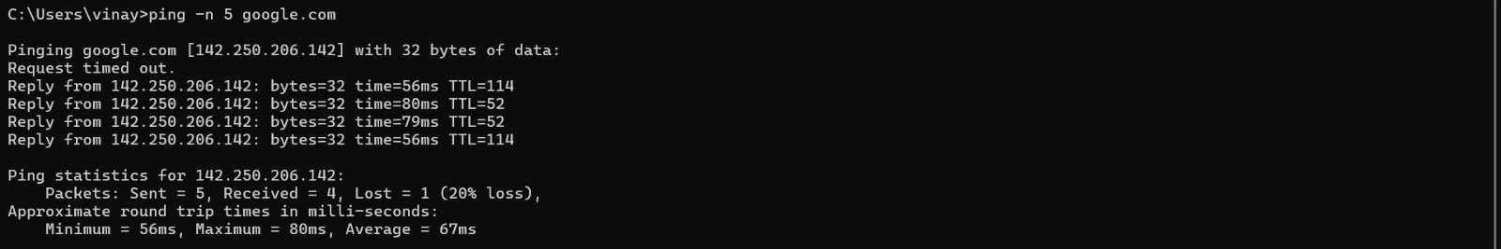

**-l (size)**

**Explanation:**

* Sets the size (in bytes) of the packet payload.

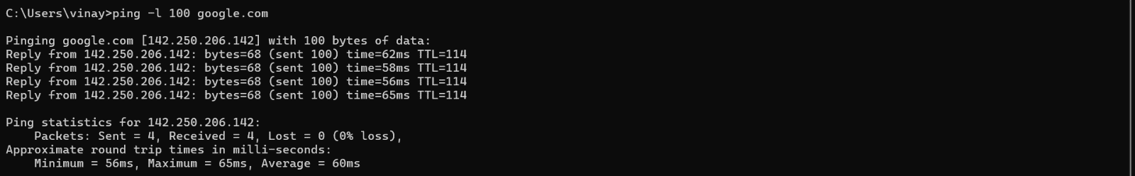

**-i (ttl)**

**Explanation:**

* Sets the Time-To-Live (TTL) for packets. On Windows, the option is -i.

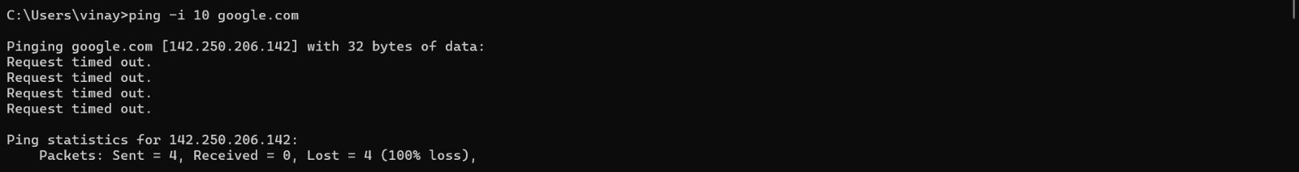

**-w (timeout)**

**Explanation:**

* Sets the timeout (in milliseconds) for each ping reply.

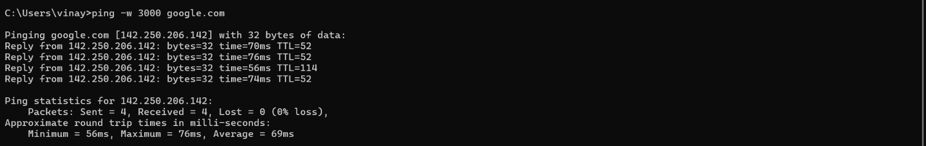

**4. Troubleshooting with Ping**

Example: A user in an office report that their internet connection is unusually slow, making it difficult to load websites and access online services. Other users on the same network do not seem to experience the same issue.

Using Ping for Diagnosis:

If a user experiences slow network speeds, start by using the ping command to test connectivity to the local router (ping 10.15.7.173) to see if the issue is within the local network. Then, ping an external website (ping www.google.com) to check for high latency or packet loss, which could indicate an issue with the ISP. Finally, compare the ping results on another device in the same network to determine if the problem is isolated to the user’s device or affects the entire network.